**Francis Micksa**

**“The influence of mathematics on the classificatory thought of S.R. Ranganathan”**

## 

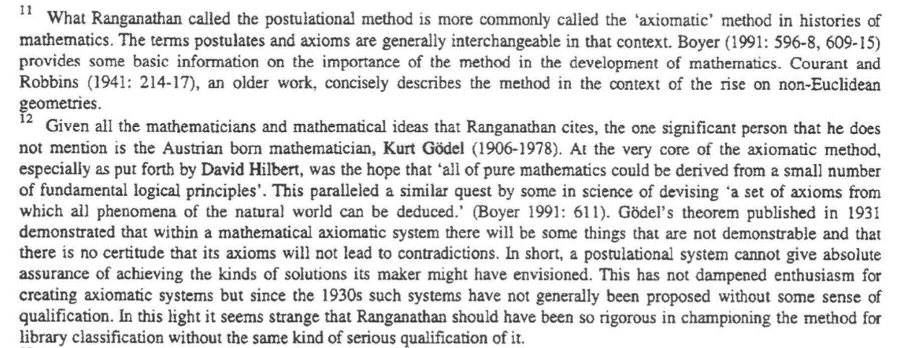

|  |
| --- |
| CHAPTER XD **5 Preventive Steps**  **51 Purification of Mathematics:** In the nineteenth century, a considerable work was done on the foundations of mathematics. The **silent assumptions were pulled out** from their hiding places. The number-concept was put on a clarified basis. Degrees of approximations were recognised. Boundary conditions were established for the validity of diverse operations. This has amounted to purification of mathematics. The **postulational** **method** is proving to be particularly effective in the elimination of errors.  **52 Purification of Logics:** Since the nineteenth century, a considerable work is being done in logic too. The creation of **symbolical calcolus** by **Boole** and the initiation of **syntactical methodology** by **Frege** and **Hilbert** in the study of the logical structure of sentences and relations between signs have been helpful steps in the purification of formal logic. The **Polish** **School** has dug up other regions of logic guided by istinct and common sense. As a result the discipline of **Semantics** is being developed to take charge of meaning, interpretation, and relation as based on meaning, in so far as logical inference is concerned.  […]  **7 Resulting versatility**  Every step in generalization and abstraction increases the versatility of a subject. This is well demonstrated in the development of mathematics. Let us take the concept of numbers. It began with positive integers. These were generalized to embrace negative numbers, rational numbers, real numbers, imaginary numbers, complex numbers, hyper-complex numbers, and transfinite numbers of different orders. In another direction, arithmetic was generalised and abstracted into the calcolus of operations and the theory of groups. This capacity to abstract and generalize without limit has enabled mathematics to become ubiquitous and make itself serviceable in any subjects whatever –whether it is in the region of physical, biolgical, or social sciences, or in the field of humanities. It is the versatility thus got by that made Gauss call it the “Queen of sciences” |

***Micksa pag 7***

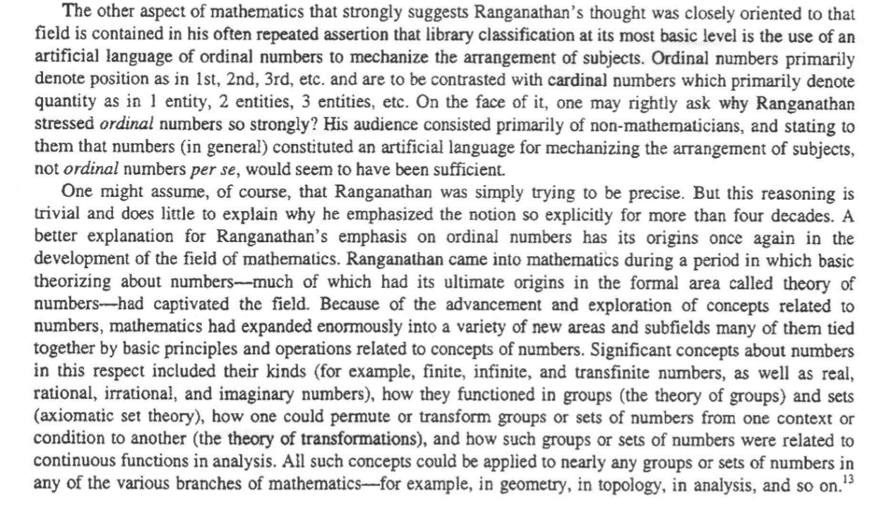

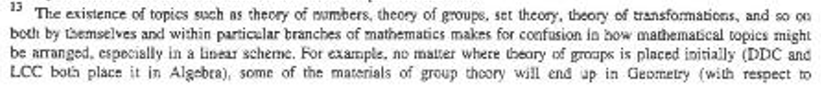

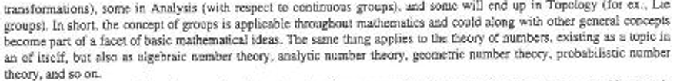

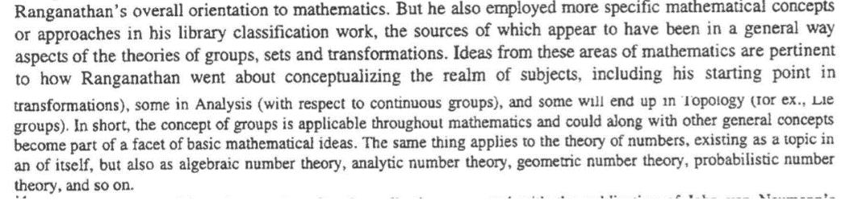

***Micksa pag 7***

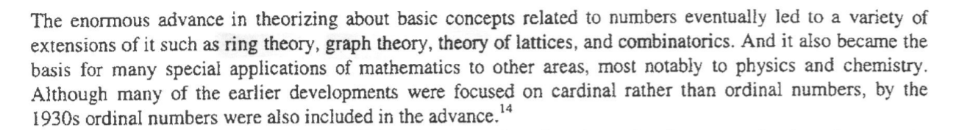

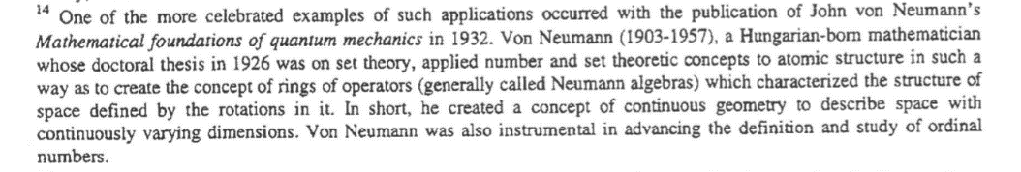

***Micksa pag 8***

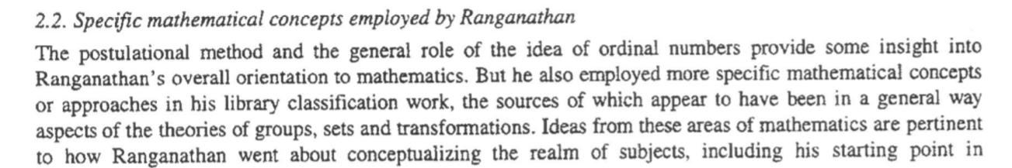



***[…]***

In mathematics, transform theory is the study of transforms, which relate a function in one domain to another function in a second domain. The essence of transform theory is that by a suitable choice of basis for a vector space a problem ***may be simplified—or diagonalized as in spectral theory.***

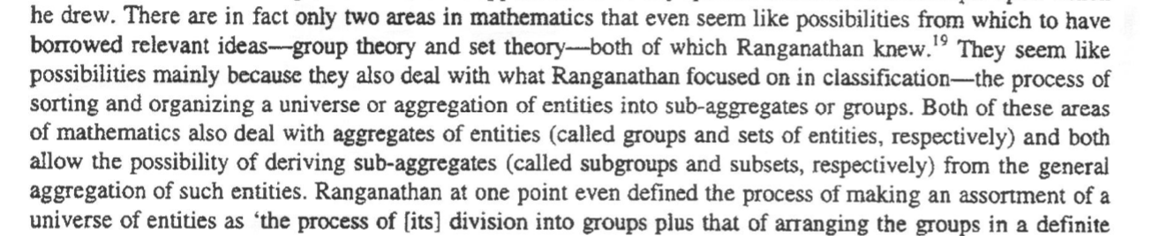

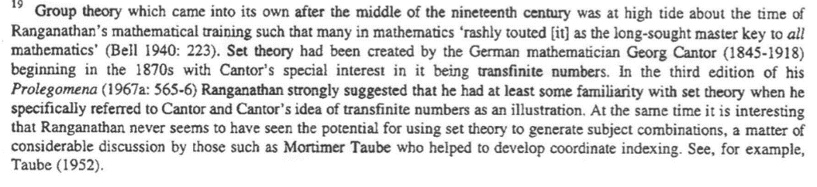

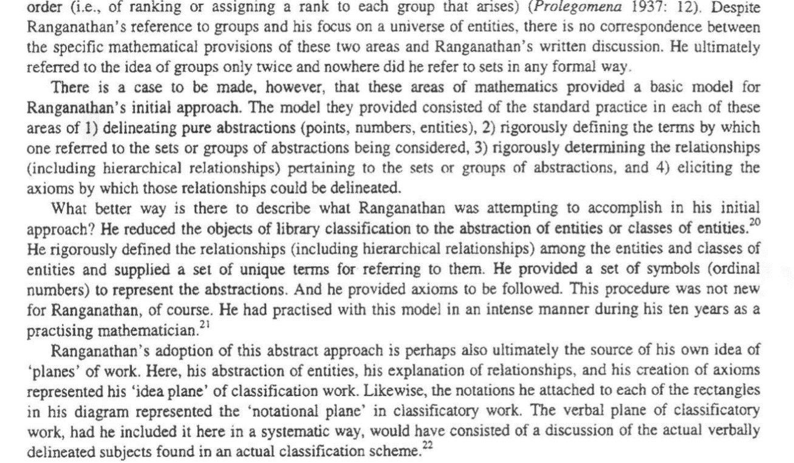

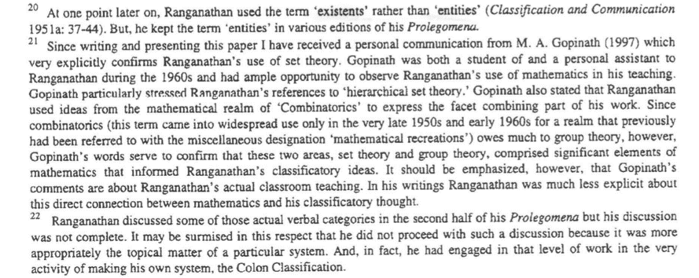

***Micksa pag 10***

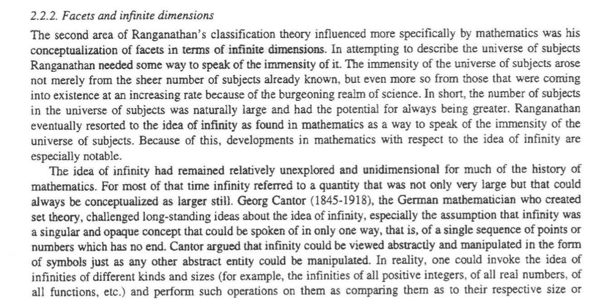

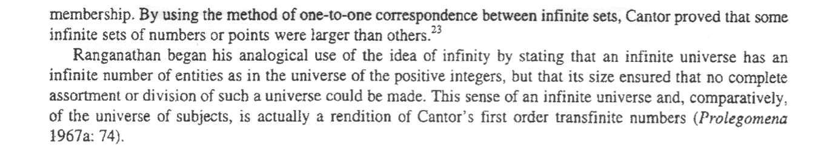

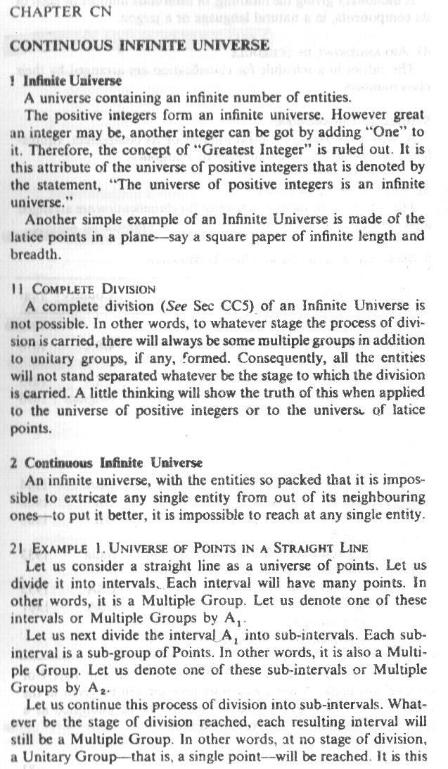

## 

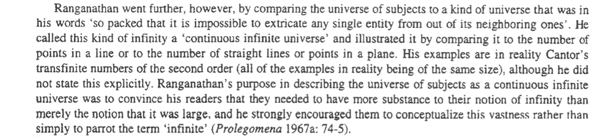

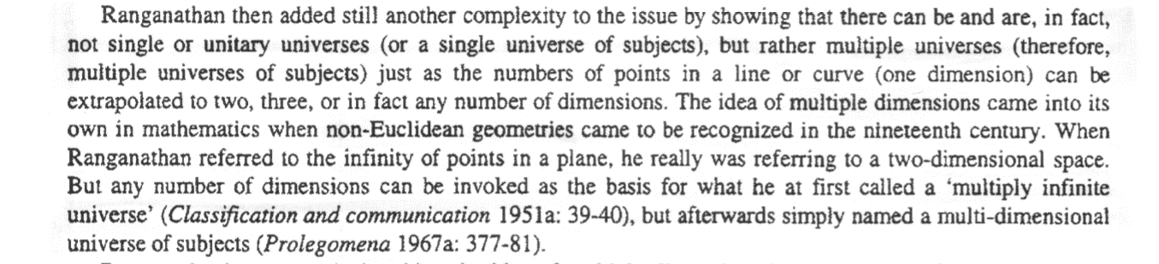

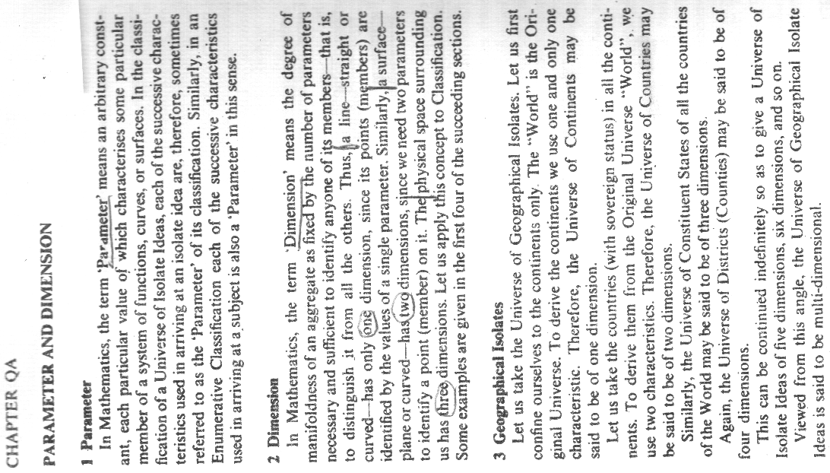

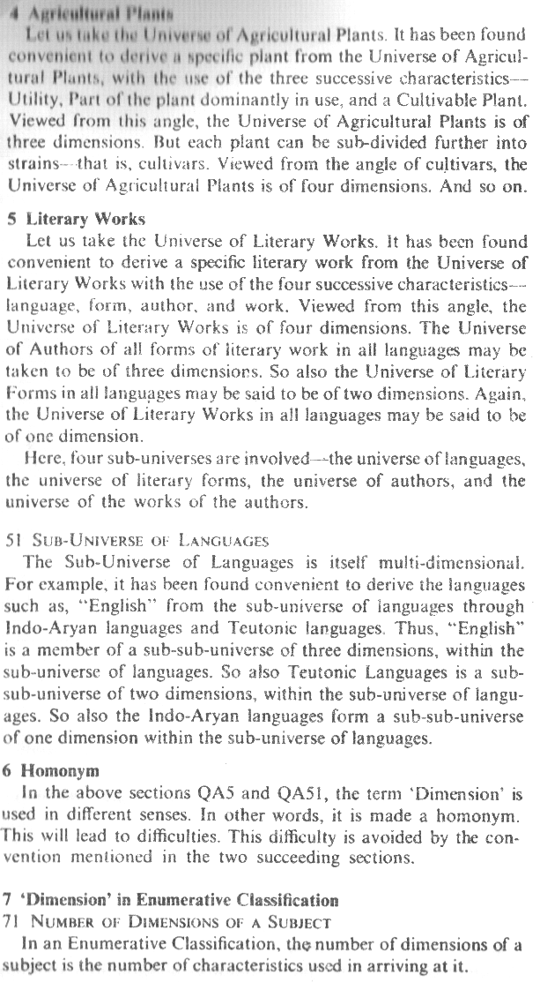

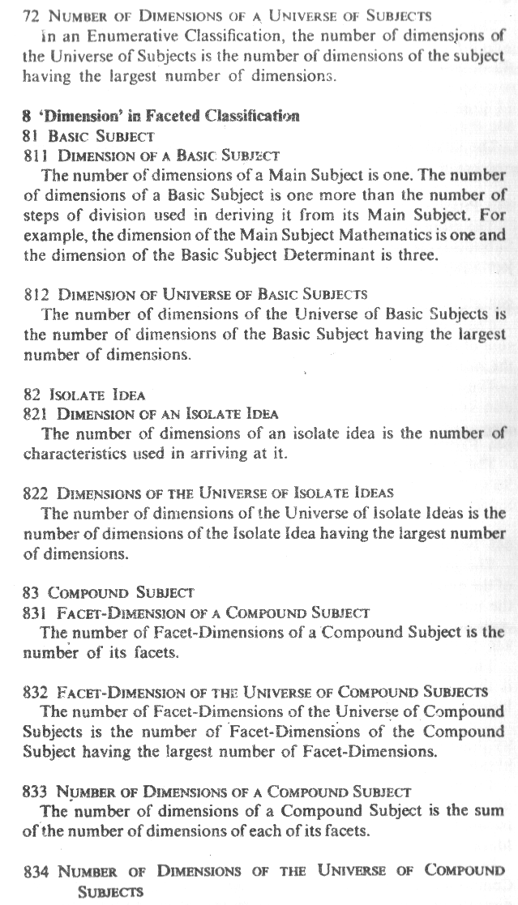

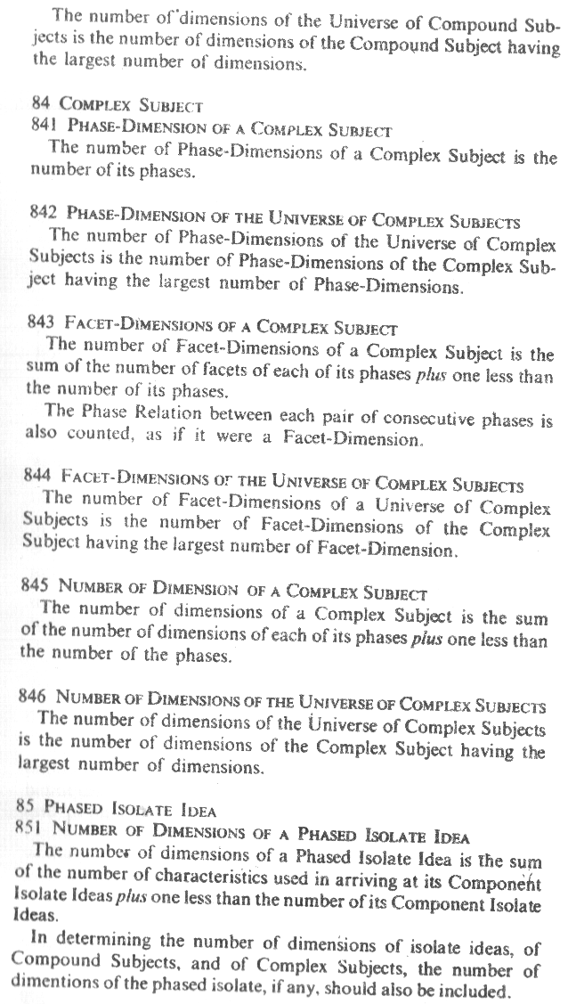

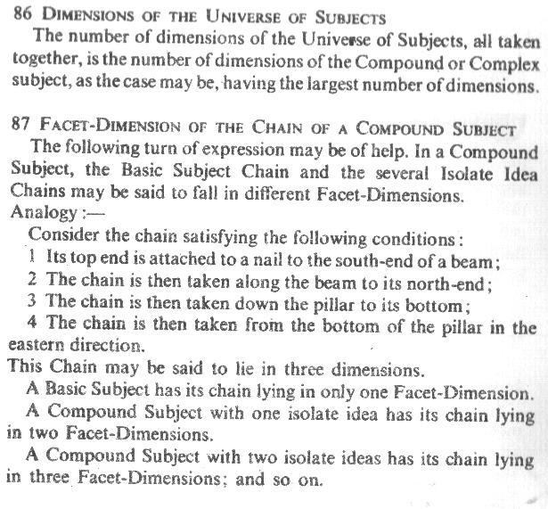

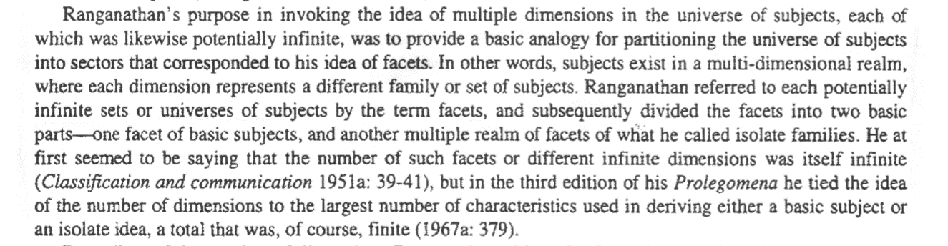

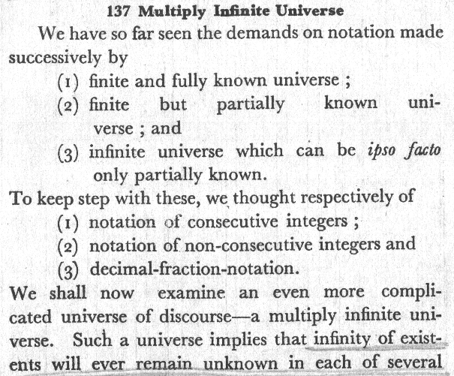

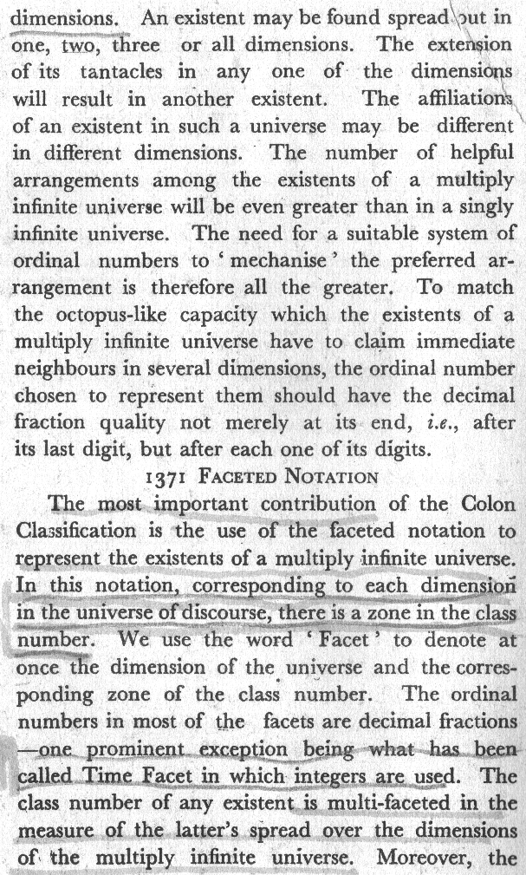

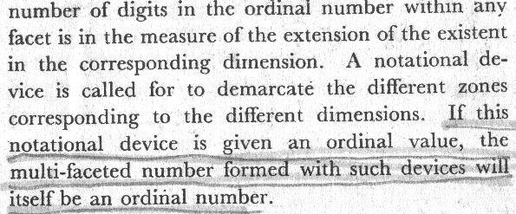

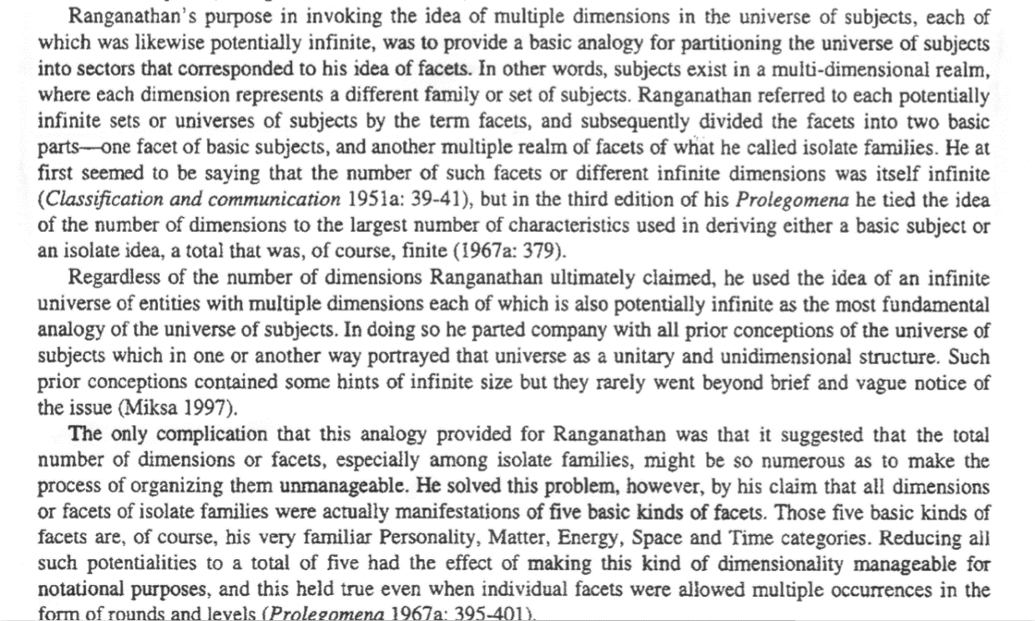

|  |
| --- |
| CHAPTER RA **[…] 6** **Status of Postulate.**  Euclid postulated that two parallel lines do not meet. For nearly twenty centuries, no one questioned this postulate. Everybody was satisfied that it was helpful to use this postulate. Everybody was satisfied that it was helpful to use that postulate. Then Came Gauss, who said, “How do you know that they not meet? Have ever you walked along them to their very end? I say that they meet there-at a far off place. Can you deny it?” Then he made his own postulate that parallel lines meet at both ends. Which of these two postulates are we to prefer? Whichever is helpful to our purpose; whichever does the job for us; that is all Until the nineteenth century, the Euclidean postulate did the job. On the other hand, experiences explained not only the experiences explaine by the Euclidean Postulate, but also some new experiences which it cannot.  **61** **Anecdote of a mathematical genius**. […] I had the unusual fortune to have an unusual boy in my class […] he found a certain figure -a parabola. He began to look at it with great interest. I asked him “What re you admiring?”. He replied: “The arms of this figure meet” […] “where do they meet?” […] “Far, far away” […] “How do you know?” […] “I have seen it” […] “When did you see it” […] “I cannot say”. |

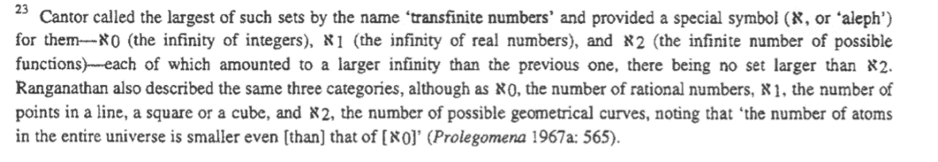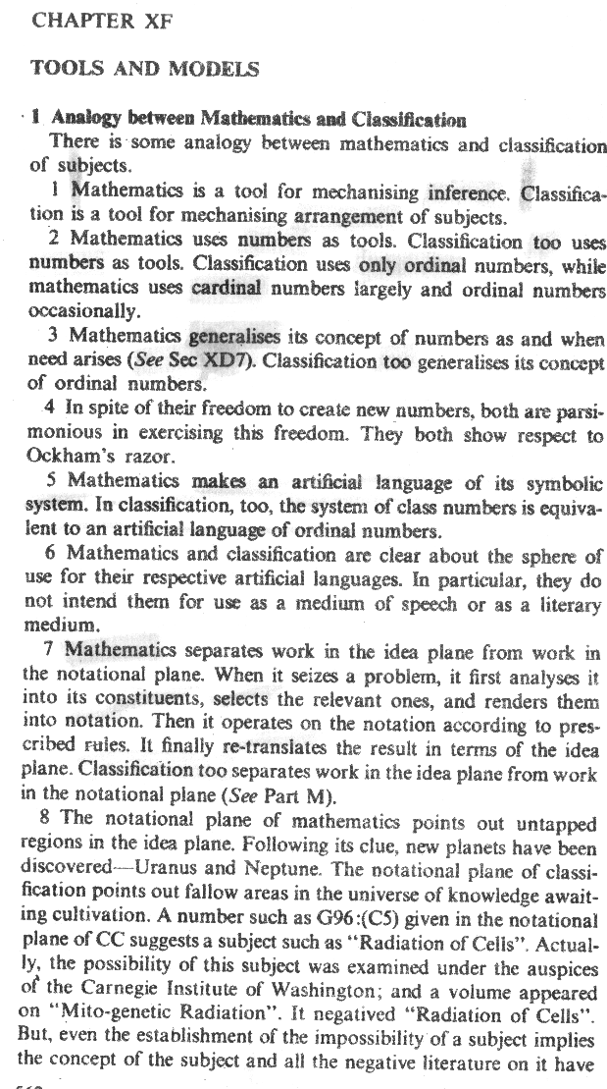

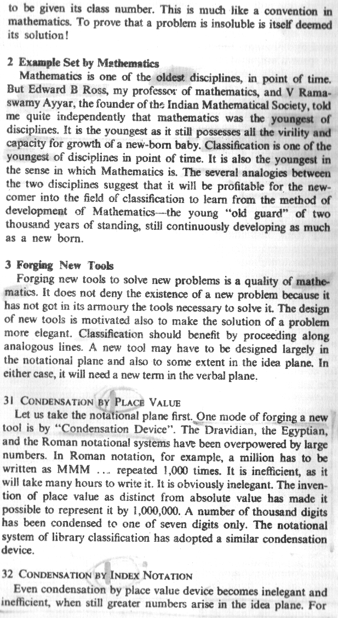

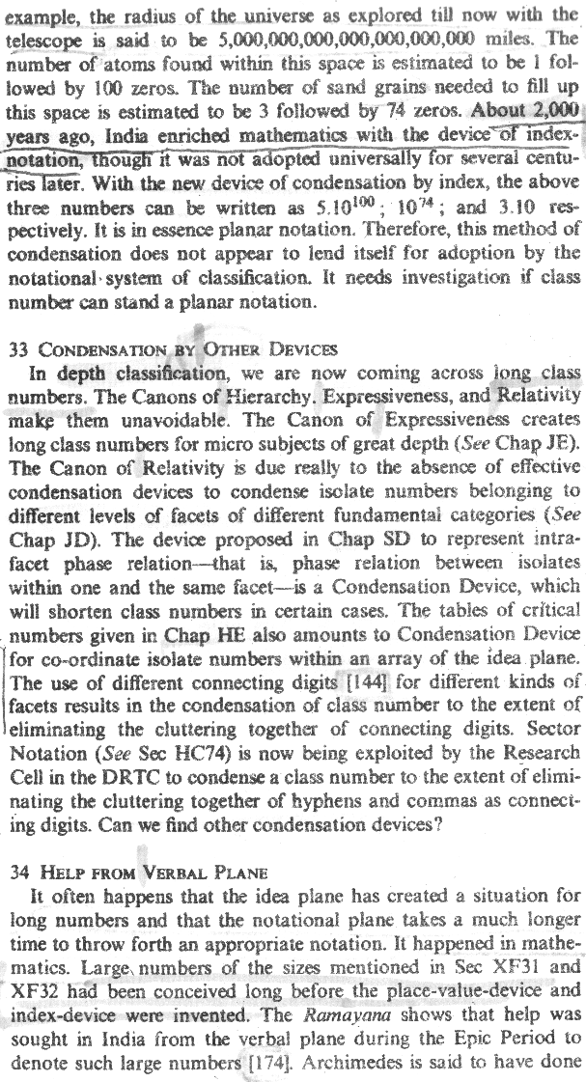

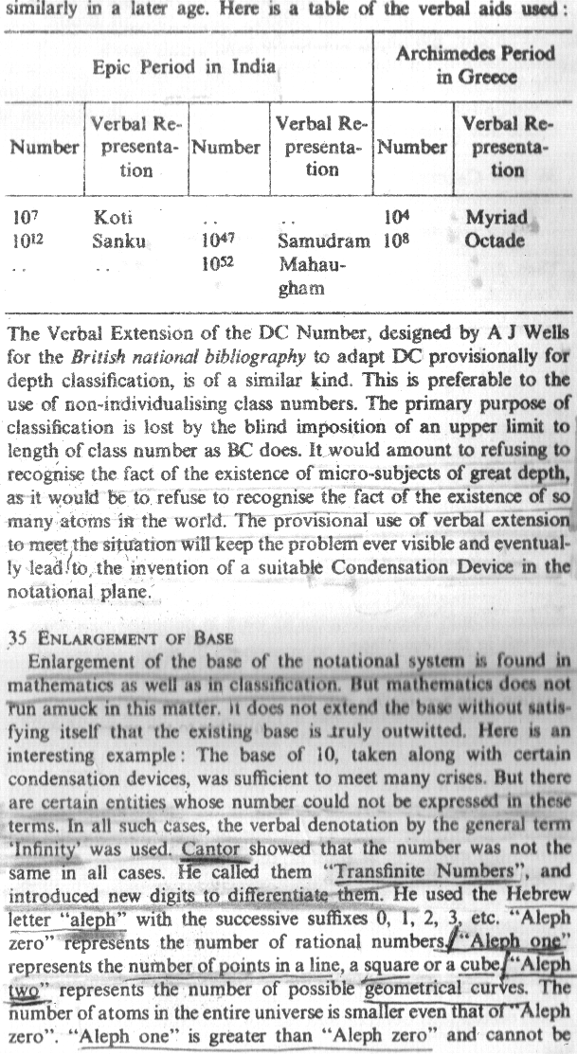

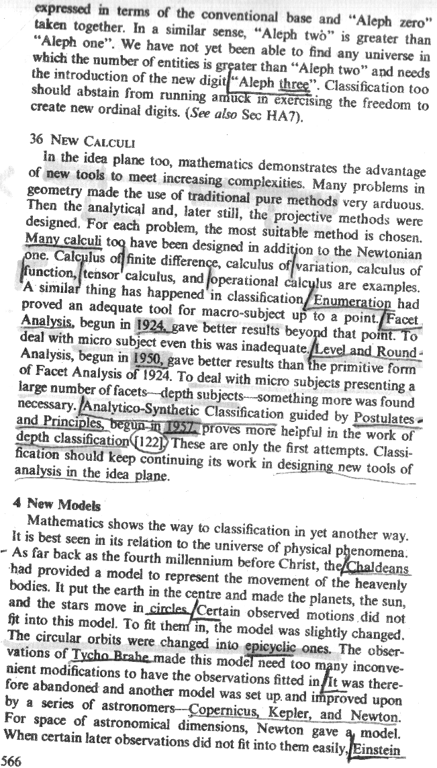

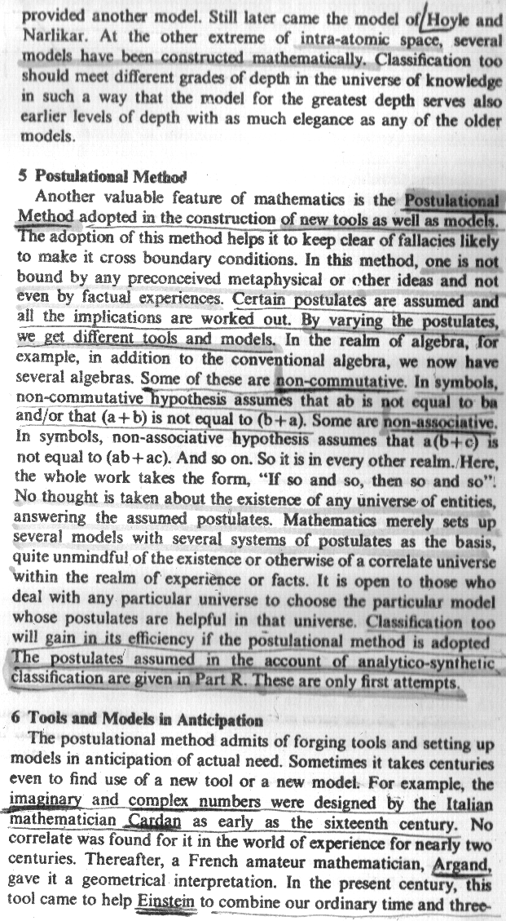

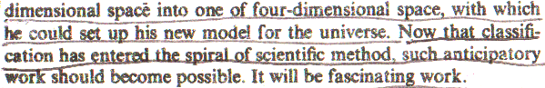

***Micksa pag 11***

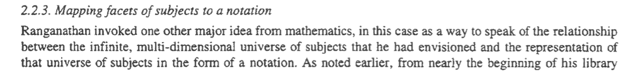

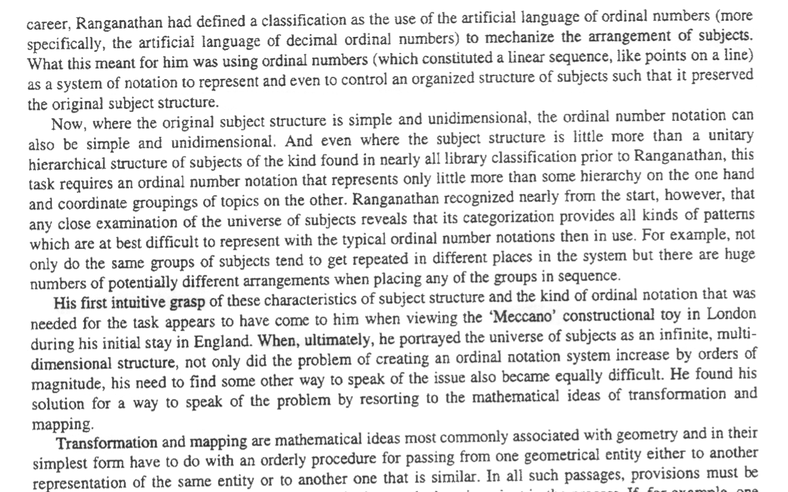

***Micksa pag 12***

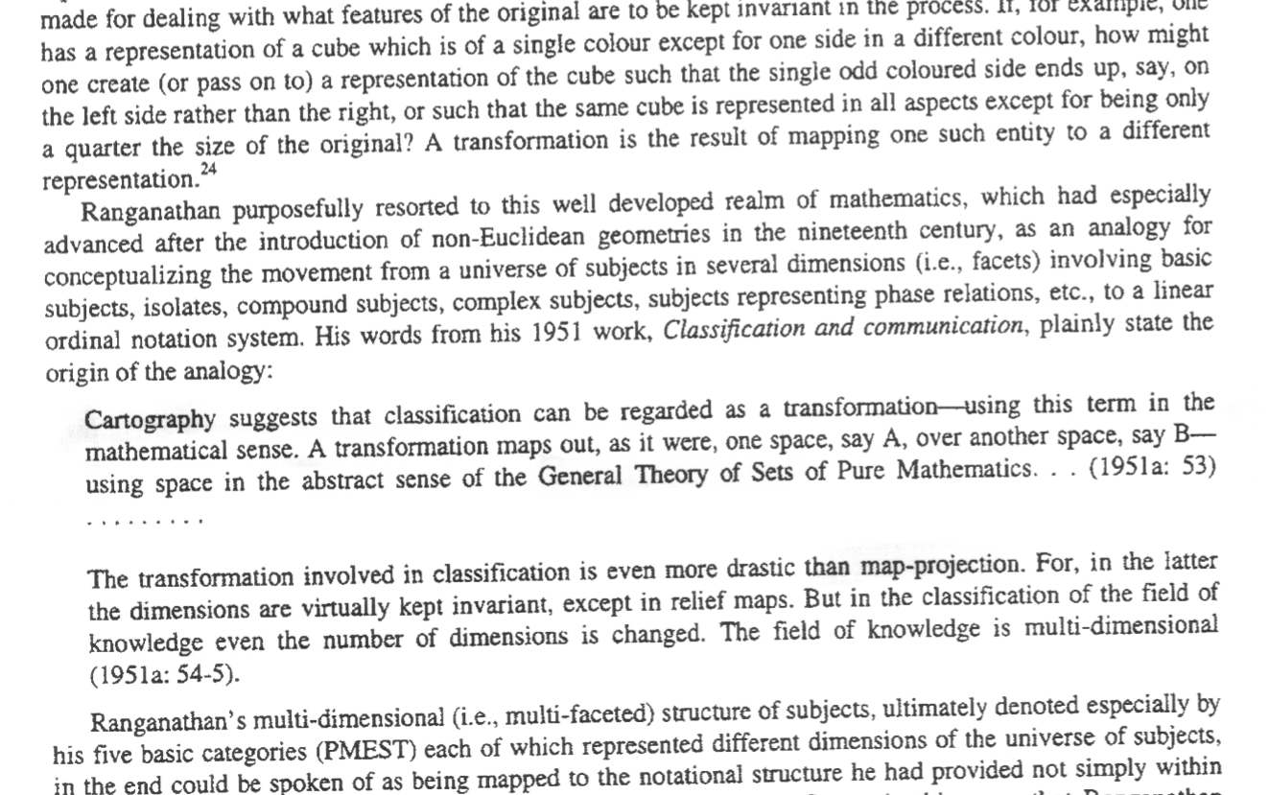

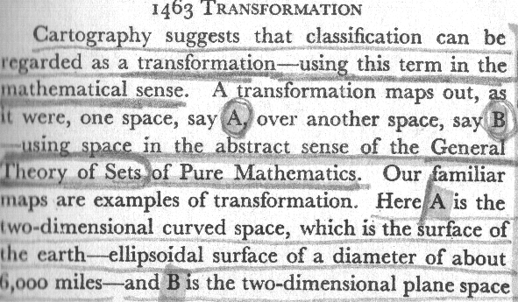

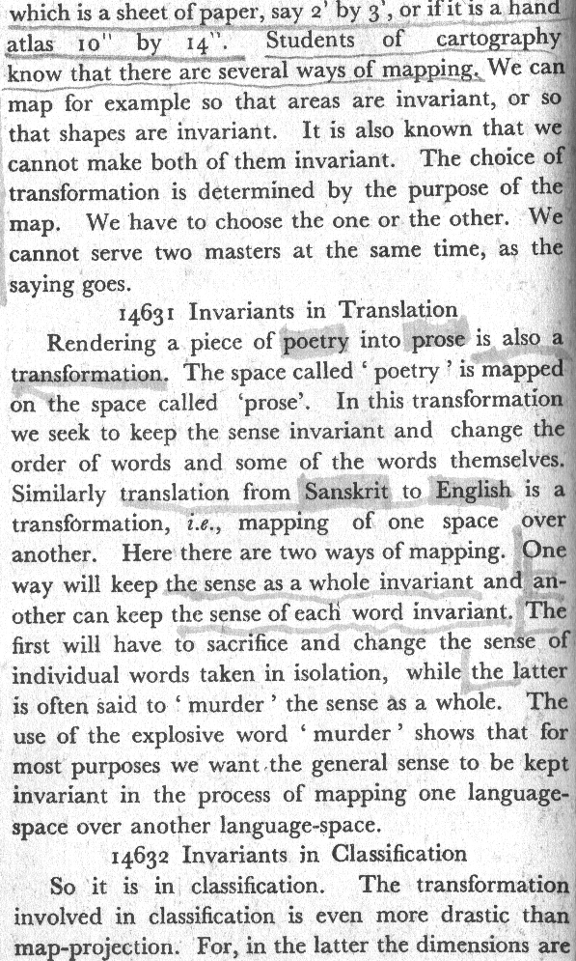

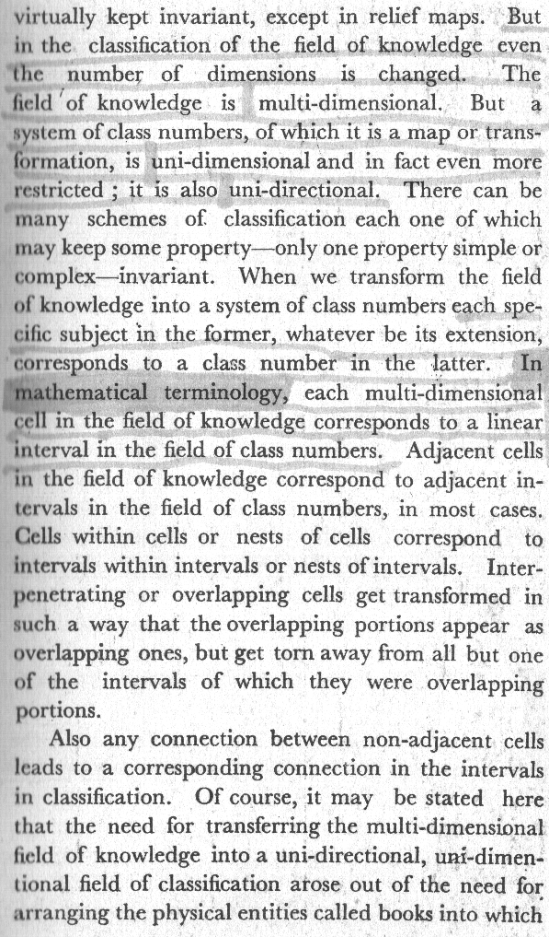

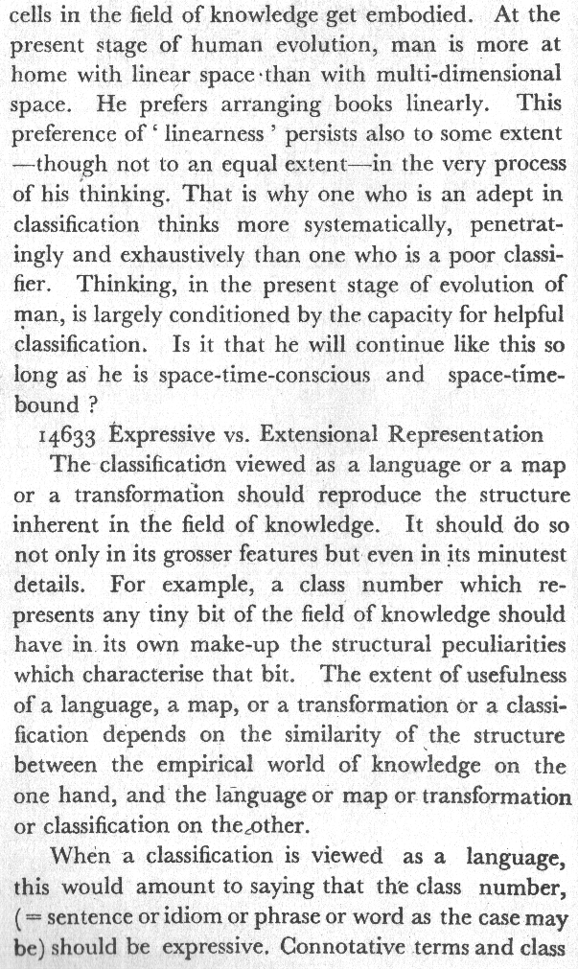

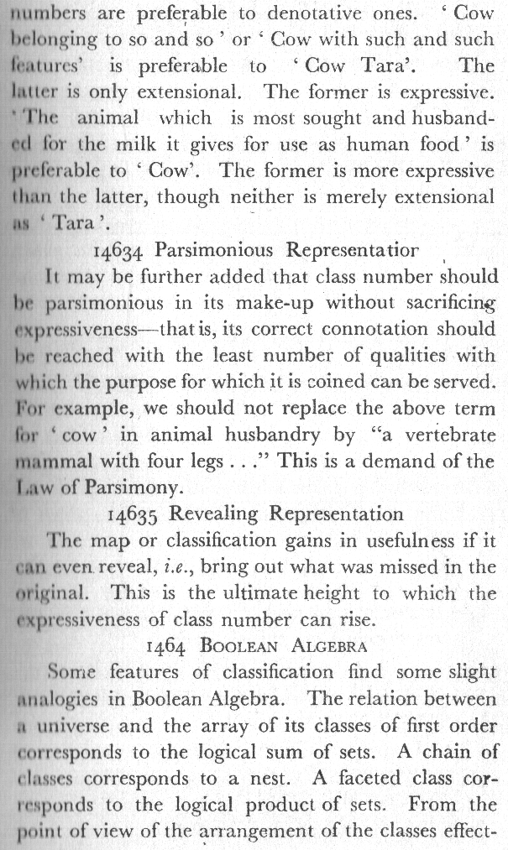

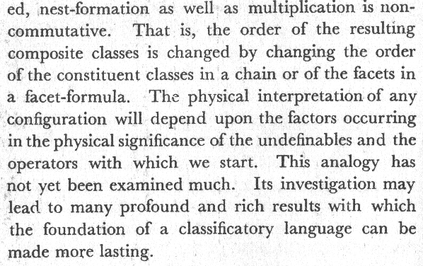

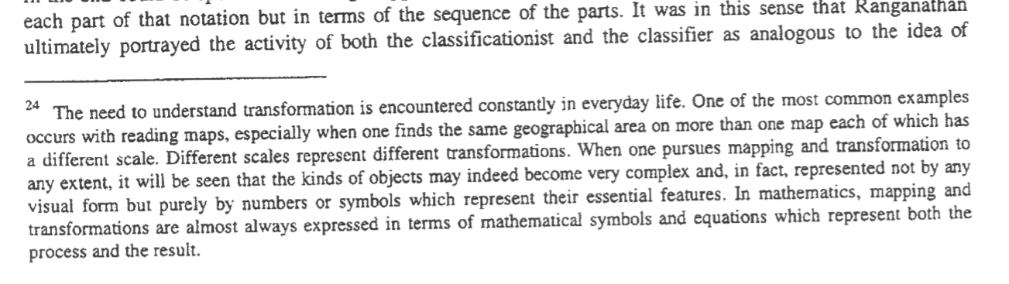



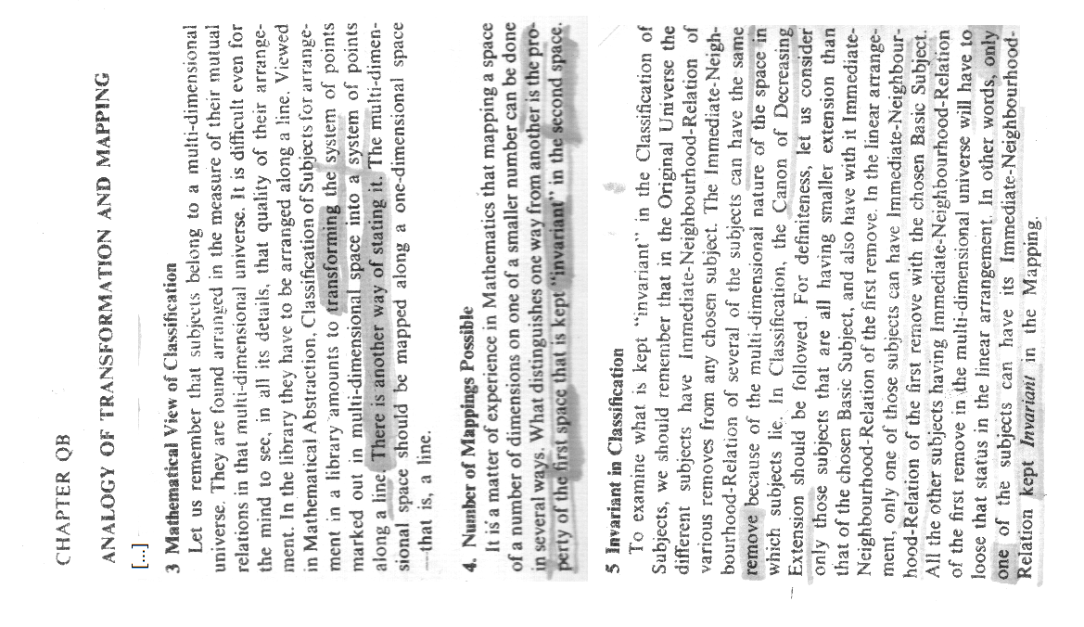

[…]

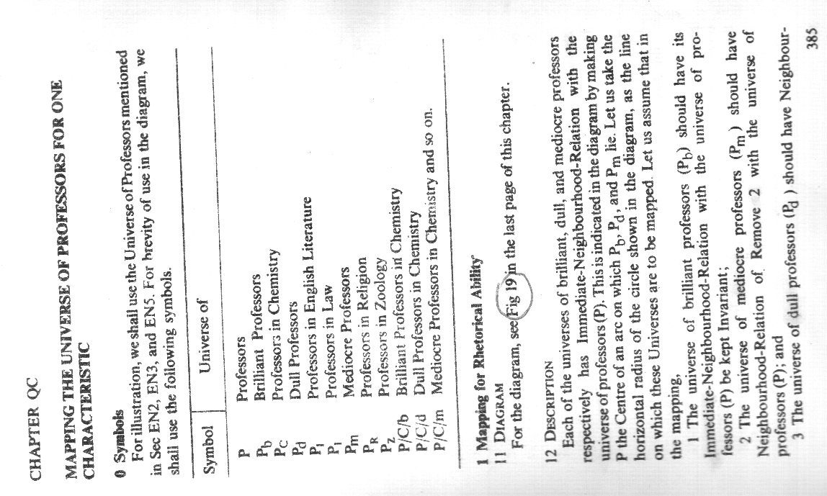

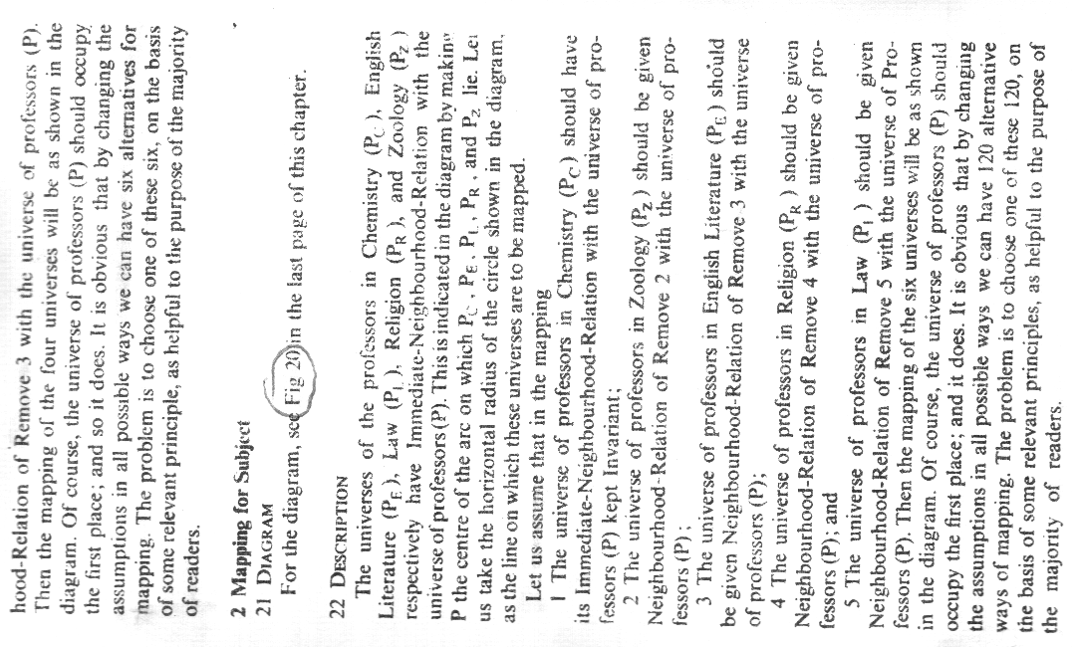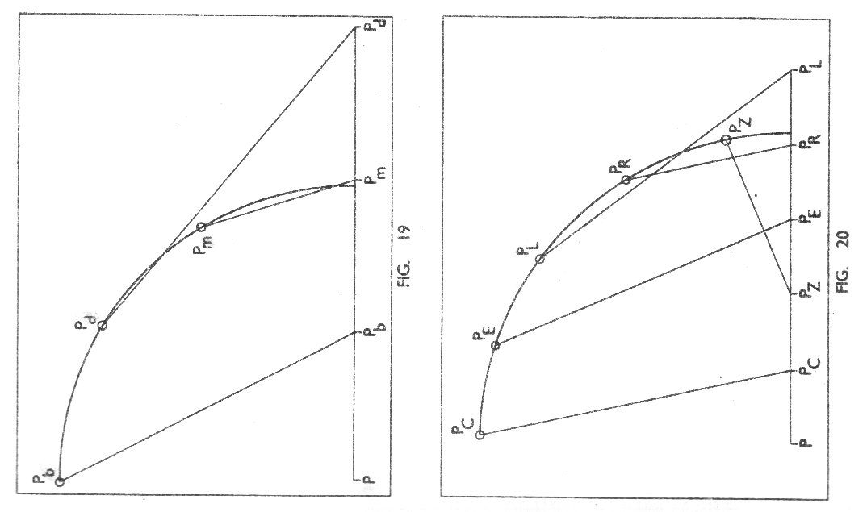

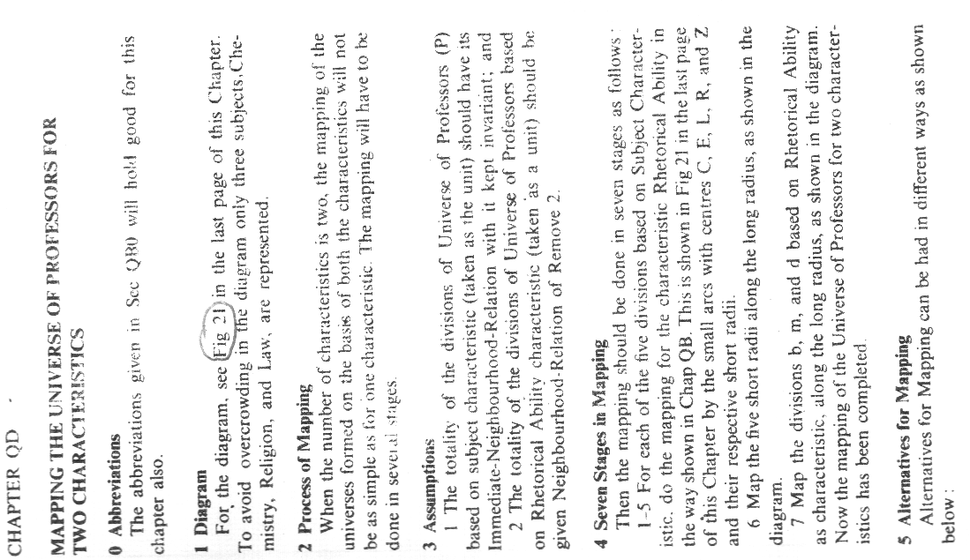

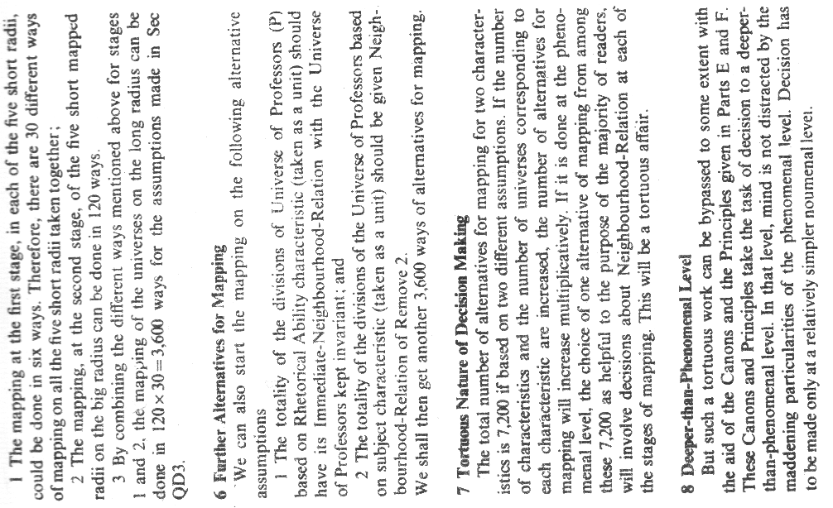

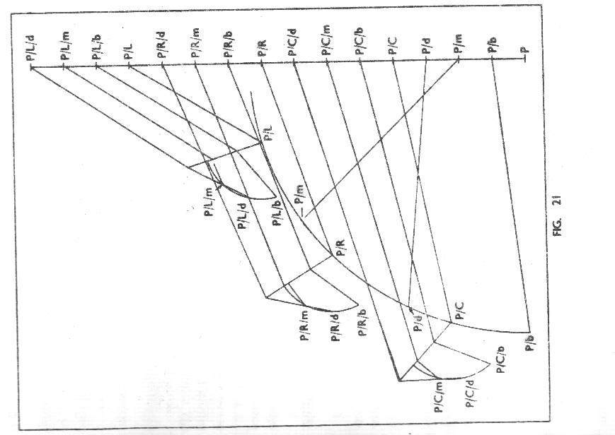

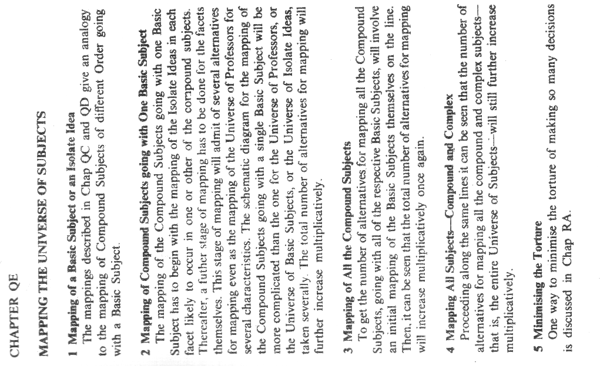

.

**Vedi sopra Chapter QA**

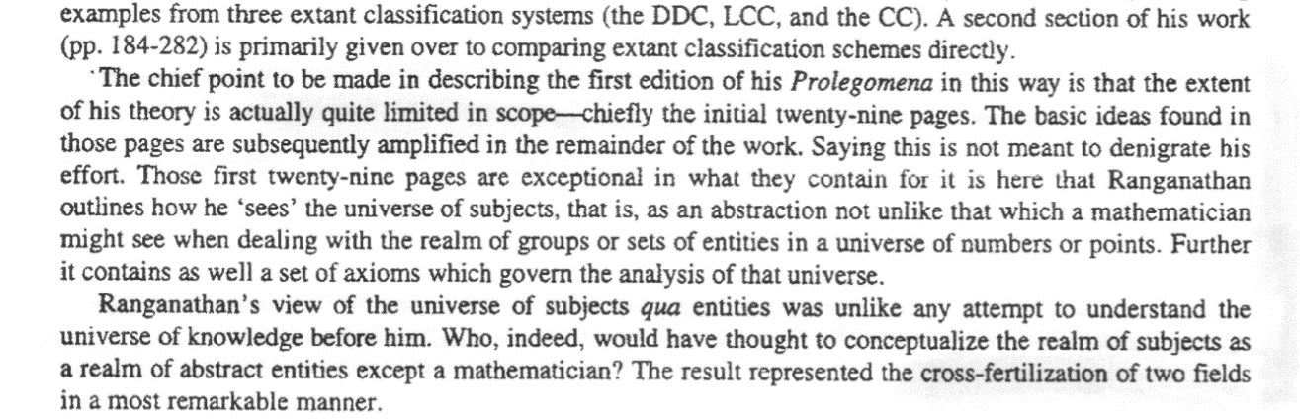

***Micksa pag 14***

# NONMETRICAL PROJECTIVE GEOMETRY

**Katerine La Barre**

A pag. 42 di “[The use of faceted analytico-syntetic theory as revealed in the practice and construction of website design](https://www.researchgate.net/publication/266274664_The_use_of_faceted_analytico-synethic_theory_as_revealed_in_the_practice_and_construction_of_website_design)” scrive:

*Members of the LRC, which formed in India in 1951, worked closely with Ranganathan on the development and continuing revision of the Colon Classification and engaged in general discussion of the problems facing library science. This group met informally each Sunday* ***on the veranda at Ranganthan’s house (Ranganathan personal correspondence, 1952)****. Questions and pragmatic problems encountered daily by the members were brought to each session for open discussion. The aim of the group was to promote classificatory principles and to “tidy up” definitions, axioms, and postulates of classificatory technique.* ***Their approach was determinedly scientific and modeled after Russell and Whitehead’s work in mathematics****. The substance of these discussions was integrated into several books, such as Depth Classification (1953) and the second edition of the Prolegomena (1957) Parthasarathy, 1952, pp. 153-159; Ranganathan, 1963, pp. 88-89). Ranganathan’s greatest contribution transcends the postulates and principles contained in these volumes and lies in his recognition of the provisional nature of systems of access and order (Kwasnik, 1992, p. 102). Ranganathan recognized the existence of a “two-fold infinity”42 in the universe of knowledge due to the multiplicity of individual worldviews and information seeking purposes as well as the infinitely complex and dynamic nature of the universe of knowledge. This duality imposes the requisite features of flexibility and responsiveness as a measure of the success of any system (Ranganathan, 1967c, p. 67).*

Sembra che Whitehead utilizzasse la teoria delle matrici nelle **trasformazioni** della **nonmetrical projective geometry**. Il loro successo fu particolarmente legato alla meccanica quantistica e alla teoria della relatività ma Ranganathan le studiò attentamente perchè cercava un modo di ricondurre per via matematico-geometrica un modo per ricondurre lo spazio multidimensionale in cui sapeva che il pensiero umano si sviluppava, alla unidimensionalità lineare che caratterizzava la disposizione dei libri sugli scaffali.

Un passo da uno scritto di Ranganathan del 1967 <https://www.isibang.ac.in/~library/portal/Pages/chp5.pdf> conferma che aveva letto “Process and reality” di Witehead e che lo pensava citabile in un testo di library science: *The right attitude is expressed in the wise epigram of A N Whitehead, "The art of progress is to preserve order amid change and to preserve change amid order"* (WHITEHEAD A.N. Process and reality, an essay in cosmology. 1923. P 515).

In questo caso cita “Principles of Mathematics” di Russell e Whitehead come esempio di pubblicazione che determina una esigenza di cambiare qualcosa nelle classificazioni discilplinari: *(2) Need has arisen to introduce a new true main class to hold materials of the kind of Whitehead and Russell s "Principles of Mathematics" which now have a periodical of their own called "Symbolic Logic". It is still perhaps without a stabilized distinctive name in natural language. Inclusion of this in the main classes Mathematics or Philosophy (which includes Logic 1 destroys the homogeneity of either and wrongs the individuality of the new discipline itself.*

**Charles van den Heuvel**

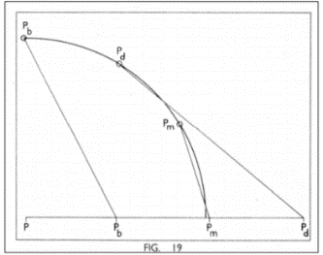

Figura : Dimension reduction (Ranganathan 1957)

Sembra riprendere il lavoro di LaBarre in [**“Multidimensional Classifications: Past and Future Conceptualizations and Visualizations”**](https://www.google.it/url?sa=t&rct=j&q=&esrc=s&source=web&cd=2&ved=0ahUKEwiays3Z69fXAhVE7xQKHZOHA28QFgg1MAE&url=https%3A%2F%2Fjournals.lib.washington.edu%2Findex.php%2Fnasko%2Farticle%2Fdownload%2F12795%2F11287&usg=AOvVaw075mQIOAo062RsC6H53FPB)

“*We do not know for sure whether they discussed the views of the latter on* ***mapping of multidimensional spaces and classification***  *as well.*

*Whitehead linkes in his*[***Adventures of Ideas (1933)***](https://books.google.it/books?id=UZeJuLvNq80C&lpg=PA137&ots=QYmGiYQtyg&dq=Whitehead%20Adventures%20of%20Ideas%20non-metrical%20projective%20geometry%2C%20science%20of%20cross-classification&hl=it&pg=PA136#v=onepage&q&f=false)***“non-metrical projective geometry” to what he called “the science of cross-classification.” (Whitehead 1967****, 137-38)*

***Different from elementary geometry of Euclidian space, non metric projective geometry has a projective space. In this space, geometric transformations are permitted to move "points at infinity” to traditional points, and vice versa that are not permitted in Euclidian space. (Wikipedia 2011)***

*Ranganathan’s description of how the successive isolates in a chain within a facet, considered*

* *rom the angle of the idea plane, form a “****Nest of Cells in many dimensions****” and*
* *from the notational plane a “****Nest of Intervals on a line****”*

*might have been inspired by Whitehead’s views on projective geometry. (****Ranganathan 1957****, 254-255)*

*Although Ranganathan recognized the existence of a* ***“two-fold infinity”*** *–*

* *an infinity in the* ***approaches of readers*** *of documents*
* *and an infinity in the* ***dimensions of the universe of ideas*** *to be organized (LaBarre 2006, 43)*

*he seems to exploit the method of projective geometry in a one directional way*

*i.e. the* ***transformation from more dimensions to one****,*

## Whitehead: da THE AXIOMS OF PROJECTIVE GEOMETRY (1906)

<https://download.tuxfamily.org/openmathdep/geometry_projective/Axioms_Projective_Geometry-Whitehead.pdf>

*A Geometry will be called 'Projective' if two coplanar lines necessarily intersect.*

*Thus Euclidean Geometry is not projective, but becomes so when the various entities called the points at infinity on the various lines have been defined, and added to the other points on the lines.*

*It will be found that the appropriate kind of linear order for a projective geometry is that of a closed series.*

*A non-projective Geometry will be called a Descriptive Geometry.*

*The appropriate kind of linear order for a descriptive geometry is that of an open series.*

*In Projective Geometry the subject viewed simply as a study of classification has great interest.*

*Thus in the foundations of the subject this conception is emphasized, while the introduction of 'order' is deferred. The opposite course is taken in Descriptive Geometry since the purely classificatory part of the subject is clumsy and uninteresting.*

***CHAPTER II.***

***AXIOMS OF CLASSIFICATION.***

*4. Throughout the rest of this tract we are concerned solely with Projective Geometry.*

*Thus, following the careful method of enunciation of the* ***Italian school of writers on this subject (Cf. I Principii delta Geometria di Posizione, by M. Pieri, Aecad. B. di Torino, 1898.)****, we take as undefined ideas that of 'a point' and that of 'a line’ joining a point A with a point B'; also the line joining A with B will be denoted by ^4 B.*

*Then the following axioms are to be assumed:*

*I. Points form a class of entities.*

*II. There is at least one point.*

*III. If J. is a point, there is a point not identical with A.*

*IV. and V. If A and B are distinct points, the line ^^ is a class, and all its*

## Mario Pieri: da “[principi della geometria di posizione](https://archive.org/stream/AttiDellaRAccademiaDelleScienzeTorino39/Atti_della_R_Accademia_delle_scienze_Torino_39#page/n7/mode/2up)” (1904)

**Testo citato da Withehead nel testo sopra (Reale Accademia delle Scienze di Torino 1904)**

**Metodo postulazionale (**[**vedi testo su Google Books**](https://books.google.it/books?id=-UzKwHWzdesC&pg=PA81&lpg=PA81&dq=fieri+peano&source=bl&ots=vLi6pt65aH&sig=Kq3UzgGbCaa4lusf-pKdvlIQ-9Y&hl=it&sa=X&ved=0ahUKEwj28KmK99bYAhUO36QKHRUFDhoQ6AEIOjAH#v=onepage&q=fieri%20peano&f=false)**)**

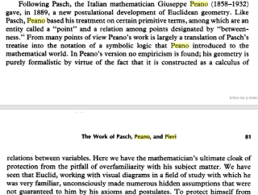

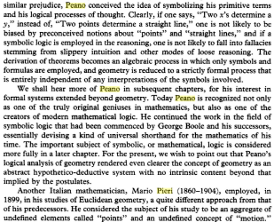

## <https://en.wikipedia.org/wiki/Projective_geometry>

**Projective geometry** is a topic in [mathematics](https://en.wikipedia.org/wiki/Mathematics). **It is the study of geometric properties that are invariant with respect to** [**projective transformations**](https://en.wikipedia.org/wiki/Projective_transformation).

This means that, compared to elementary geometry, projective geometry has a different setting, [projective space](https://en.wikipedia.org/wiki/Projective_space), and a selective set of basic geometric concepts.

The basic intuitions are that **projective space has *more* points than** [**Euclidean space**](https://en.wikipedia.org/wiki/Euclidean_space)**, for a given dimension, and that** [**geometric transformations**](https://en.wikipedia.org/wiki/Geometric_transformation) **are permitted that transform the extra points (called "**[**points at infinity**](https://en.wikipedia.org/wiki/Point_at_infinity)**") to Euclidean points, and vice versa**.

Properties meaningful for projective geometry are respected by **this new idea of transformation, which is more radical in its effects than can be expressed by a** [**transformation matrix**](https://en.wikipedia.org/wiki/Transformation_matrix) **and** [**translations**](https://en.wikipedia.org/wiki/Translation_(geometry)) **(the** [**affine transformations**](https://en.wikipedia.org/wiki/Affine_transformation)**)**.

The first issue for geometers is what kind of geometry is adequate for a novel situation.

**It is not possible to refer to** [**angles**](https://en.wikipedia.org/wiki/Angle) in projective geometry as it is in [Euclidean geometry](https://en.wikipedia.org/wiki/Euclidean_geometry), because **angle is an example of a concept not invariant** with respect to projective transformations, as is seen in [perspective drawing](https://en.wikipedia.org/wiki/Perspective_drawing).

One source for projective geometry was indeed the **theory of perspective**.

Another difference from elementary geometry is the way in which [parallel lines](https://en.wikipedia.org/wiki/Parallel_(geometry)) can be said to meet in a [point at infinity](https://en.wikipedia.org/wiki/Point_at_infinity), once the concept is translated into projective geometry's terms. Again this notion has an intuitive basis, such as railway tracks meeting at the horizon in a perspective drawing. See [projective plane](https://en.wikipedia.org/wiki/Projective_plane) for the basics of projective geometry in two dimensions.

**While the ideas were available earlier, projective geometry was mainly a development of the 19th century.**

## Testi sulla geometria proiettiva e multidimensionale

* **Projective Geometry with Cliﬀord Algebra** DAVID HESTENES and RENATUS ZIEGLER <http://geocalc.clas.asu.edu/pdf/PGwithCA.pdf> **Cliﬀord algebra** is the mathematical backbone of **geometric calculus**. The mistaken belief that Cliﬀord algebra applies only to metric spaces has severely retarded recognition of its general utility. We hope to dispel that misconception once and for all by demonstrating the utility of Cliﬀord algebra **for expressing the** **nonmetrical concepts of projective geometry**. This strengthens the claim, already well grounded, that Cliﬀord algebra should be regarded as **a universal geometric algebra**. To emphasize its geometric signiﬁcance, we will henceforth refer to Cliﬀord algebra by the descriptive name **geometric algebra**, as Cliﬀord himself originally suggested. […] The main purpose of this article is to set the stage for a complete treatment of projective geometry with the language and techniques of geometric algebra.
* **Universal geometric agebra** DAVID HESTENES <https://www.researchgate.net/profile/David_Hestenes/publication/265424668_UNIVERSAL_GEOMETRIC_ALGEBRA/links/551ec6f00cf29dcabb0836e0.pdf> Alfred North Whitehead promoted the idea of UNIVERSAL ALGEBRA in his monumental treatise of 1897 [1]. He proposed two candidates for this lofty title, the algebra of Boole and Grassmann's Algebra of Extension. Boolean algebra has since secured universality status in Set Theory and Symbolic Logic, although only the former is universally known and used by mathematicians. However, Whitehead's work on Grassmann Algebra, which ironically is much the larger portion of his treatise, has been almost totally ignored.
* **Performance of multidimensional space-filling curves** <http://www-users.cs.umn.edu/~mokbel/papers/SFCMove.pdf>

## Whitehead: da ADVENTURE OF IDEAS (1967)

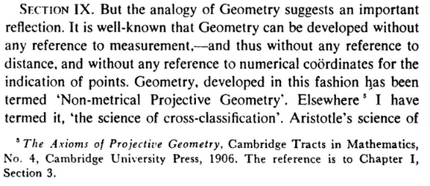

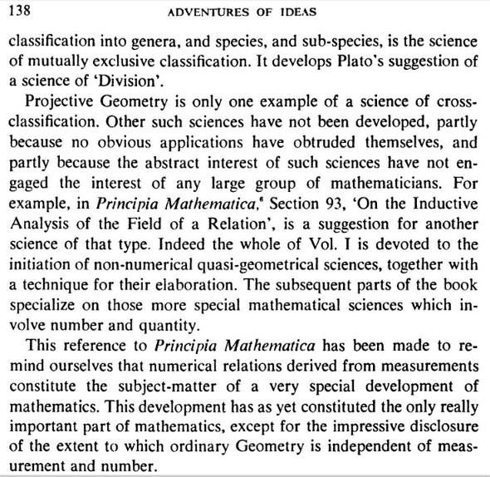

## Whitehead: da THE AXIOMS OF PROJECTIVE GEOMETRY (1906)

**3. Geometry, in the widest sense** in which it is used by modern mathematicians, is a department of what in a certain sense may be called the general science of classification.

This general science may be defined thus: **given any class of entities K, the subclasses of K form a new class of classes, the science of classification is the study of sets of classes selected from this new class so as to possess certain assigned properties.**

For example, in the traditional Aristotelian branch of classification by species and genera, the selected set from the class of subclasses of ^STare

(1) to be mutually exclusive, and

(2) to exhaust K\ the subclasses of this set are the genera of K\ then each genus is to be classified according to the above rule, the genera of the various genera of K being called the various species of K\ and so on for subspecies, etc.

The importance of this process of classification is obvious, and is sufficiently emphasized by writers on Logic.

If the genera are defined not as subclasses of K, but as classes with the corresponding species for their members, i.e. as classes of classes, and the species as classes with the corresponding subspecies for their members, and so on, till the lowest type of subspecies have members of K for their members, **we obtain a hierarchy of classes which it is essential to consider in dealing with the general theory of cardinal numbers**.

This fact illustrates further the importance of this traditional system.

The Geometrical system of classification is yet more rich in intrinsic mathematical properties, and dominates all external existence.

**Geometry is the science of cross classification.**

**The fundamental class K, is the class of points; the selected set of subclasses of K is the class of (straight) lines.**

This set of subclasses is to be such that any two points lie on one and only one Kne [**line**?], and that any line possesses at least three points.

**These properties of straight lines represent the properties which are common to aU [all?] branches of the science** which usage terms Geometrical, when the modem [modern?] Geometries with finite numbers of points are taken account of.

But no interesting general Geometric science exists in which no other axioms are assumed.

The interest of Geometry lies entirely in the development and comparison of its various branches.

**Most of the important Geometries include,** either as an undefined fundamental relation or as a relation defined in terms of the fundamental concepts, **the idea of the order of points on a line.**

**Now a linear sequence (or series) can be either open or closed**.

* A **closed series** returns into itself, like the points on the circumference of a circle ;
* an **open series** does not return into itself, like the series of integers arranged in ascending order of magnitude.

The leading division in those Geometries, which include the order of points on lines, arises according as the **straight lines are taken to be open series, or closed series.**

A definition of a **plane** can be given which holds for every geometry, namely : If A, B, C are three non-collinear points, the plane ABC is the class of points, such as JT, which satisfies the condition that some line through X intersects at least two of the lines BC, CA, AB, not at J. or ^ or C. But this definition is unnecessarily clumsy in particular Geometries, and can be replaced by more suitable special forms.

**Also one or more axioms respecting the intersection of lines in planes are required.**

**Here again a division among Geometries is reached, according as any two coplanar lines are, or are not, necessarily to intersect.**

**A Geometry will be called 'Projective' if two coplanar lines necessarily intersect.**

**Thus Euclidean Geometry is not projective, but becomes so when the various entities called the points at infinity on the various lines have been defined, and added to the other points on the lines.**

**It will be found that the appropriate kind of linear order for a projective geometry is that of a closed series.**

**A non-projective Geometry will be called a Descriptive Geometry.**

**The appropriate kind of linear order for a descriptive geometry is that of an open series.**

**In Projective Geometry the subject viewed simply as a study of classification has great interest.**

**Thus in the foundations of the subject this conception is emphasized, while the introduction of 'order' is deferred. The opposite course is taken in Descriptive Geometry since the purely classificatory part of the subject is clumsy and uninteresting.**

**CHAPTER II.**

**AXIOMS OF CLASSIFICATION.**

**4. Throughout the rest of this tract we are concerned solely with Projective Geometry.**

**Thus, following the careful method of enunciation of the Italian school of writers on this subject[1],** we take as undefined ideas that of 'a point' and that of 'a line[2] joining a point A with a point B'; also the line joining A with B will be denoted by ^4 B.

Then the following axioms are to be assumed:

I. Points form a class of entities.

II. There is at least one point.

III. If J. is a point, there is a point not identical with A.

IV. and V. If A and B are distinct points, the line ^^ is a class, and all its members are points.

VI. If A and B are distinct points, the line AB is contained in the line BA.

VII. If A and B are distinct points, ^ is a member of the line AB.

VIII. If A and B are distinct points, the line AB possesses at least one point distinct from A and B.

IX. If A and B are distinct points, and C is a point, distinct from A, lying on the line AB, then B lies on the line AC.

X. If A and B are distinct points, and (7 is a point, distinct from A, lying on the line AB, then the line AC is contained in the line AB.

XL If A and B are distinct points, there is at least one point not lying on the line AB.

XII. If ^, B, C are non-coUinear points, and A' is a point on BC, distinct from B and C, and ^ is a point on CA, distinct from C and A then the lines A A' and BB" possess a point in common.

## Whitehead-Russell: da PRINCIPIA MATHEMATICA

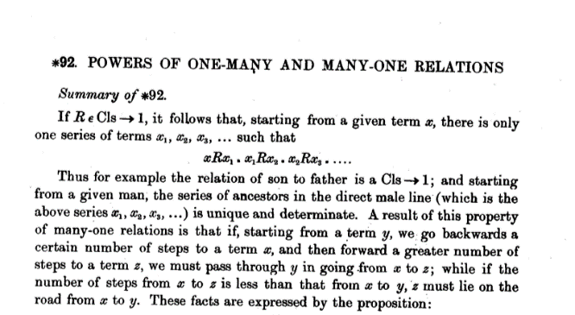

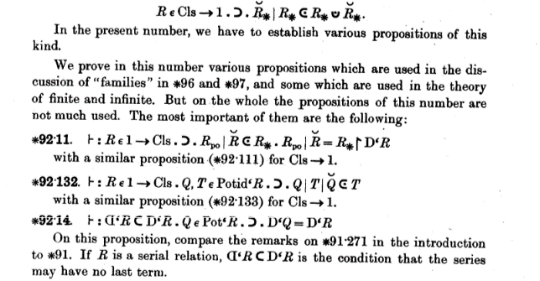

## Mario Pieri: da “PRINCIPI DELLA GEOMETRIA DI POSIZIONE” (1904)

>> Withehead rimanda al testo di Fieri sui [principi della geometria di posizione](https://archive.org/stream/AttiDellaRAccademiaDelleScienzeTorino39/Atti_della_R_Accademia_delle_scienze_Torino_39#page/n7/mode/2up) (Reale Accademia delle Scienze di Torino 1904)

**Metodo postulazionale**

<https://books.google.it/books?id=-UzKwHWzdesC&pg=PA81&lpg=PA81&dq=fieri+peano&source=bl&ots=vLi6pt65aH&sig=Kq3UzgGbCaa4lusf-pKdvlIQ-9Y&hl=it&sa=X&ved=0ahUKEwj28KmK99bYAhUO36QKHRUFDhoQ6AEIOjAH#v=onepage&q=fieri%20peano&f=false>

## Ranganathan: ZERO PIU’ GRANDE, ELISSE, GEOMETRIA DELLE CONICHE

**Projection of the circle**

“*This resemblance is not necessarily one of exact form, but just* ***as the ellipse, hyperbola, and parabola are projections of the circle*** *in the sense that there is a natural and fixed law of connection between them, so that every point of one corresponds by a certain relation with every point of the other, so the resemblance between the sensation and the quality of the object is always in the form of a fixed law o order, which, however unkown to us it may now be, is capable of being found out*”.

Determinants and linear trasformation

[*https://mathinsight.org/****determinant_linear_transformation***](https://mathinsight.org/determinant_linear_transformation)

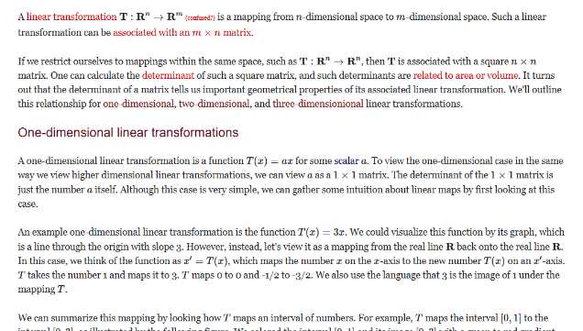

*Linear trasformation*

[*http://www.math.ubc.ca/~carrell/307_chap6.pdf*](http://www.math.ubc.ca/~carrell/307_chap6.pdf)

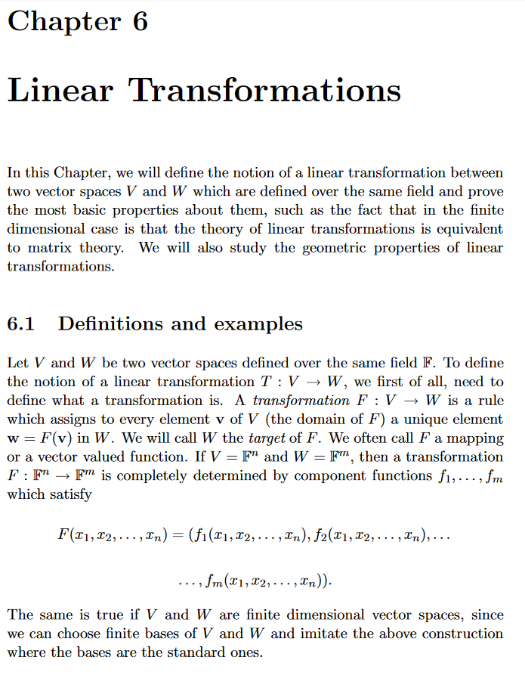

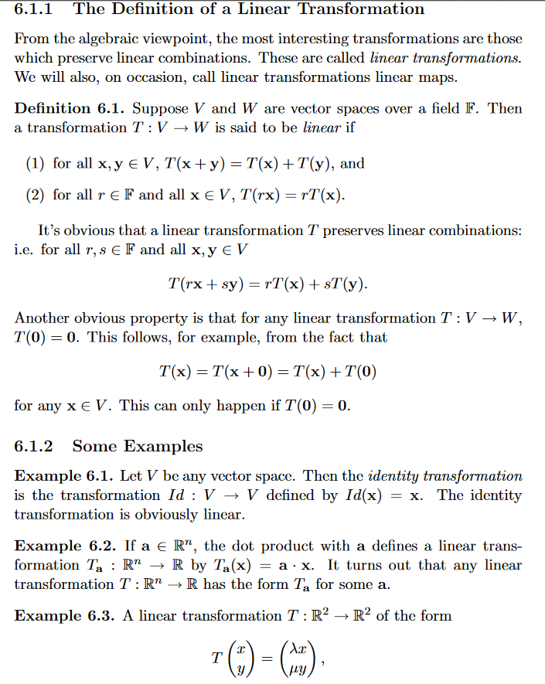

* ***Cayley’s hyperdeterminant***[*https://www.sciencedirect.com/science/article/pii/S002437951200119X*](https://www.sciencedirect.com/science/article/pii/S002437951200119X)

<https://lirias.kuleuven.be/bitstream/123456789/147436/1/41653.pdf>

1. **Cf. I Principii delta Geometria di Posizione, by M. Fieri, Aecad. B. di Torino, 1898.**
2. Note ' line ' here means the complete line and not the segment, which is introduced later. Also 'line ' is ased in the sequel habitually for ' straight line.'